Ambient Air Quality Data of Bengaluru CAAQM Stations For the month of April, 2022
Summer AQI Bulletin

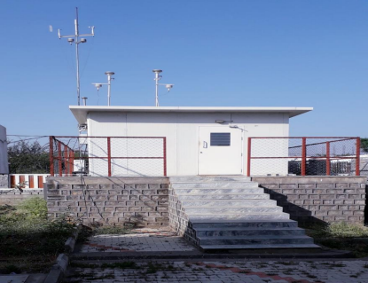

Karnataka State Pollution Control Board
No.49, Parisara Bhavan, Church Street, Bengaluru-560 001.
Website:http://kspcb.karnataka.gov.in

I N D E X
Sl.  No. | Content | Page No.
1 | Background | 1
2 | Site of CAAQM Stations operated by KSPCB in Bengaluru | 2
3 | Parameter-wise data tables of CAAQM Stations | 2,3,4,5,6
4 | Daily AQI values of CAAQMS in Bengaluru-(April-2022) | 7
5 | AQI Trend Bengaluru (April-2022) | 8
6 | Concentration ranges of Ambient Air Quality Parameters of Bengaluru CAAQM Stations | 9
7 | Air Quality Index | 9
8 | Meteorological parameters, Wind rose diagrams | 10
9 | Broad guidelines for Public | 11,12
10 | Annexure | 12
 | National Ambient Air Quality Standard (2009)
 | List of Monitoring Stations with parameters

Background: Ambient Air Quality of Bengaluru
The Ministry of Environment, Forest and Climate Change, GoI has launched the Natiional Clean Air Programme(NCAP) to tackle the Air Pollution Across the country in a comprehensive manner. 132 cities have been identified, of which 4 cities are in Karnataka, viz., Bengaluru, Hubli-Dharwad, Davangere and Kalaburgi. 44 Action points have been prepared for Bengaluru and got it approved from CPCB.
The various component contributing for Air Pollution are 1) Vehicular Movements, 2) Re-suspension of Road dust, 3) Industries, 4) C&D Waste, 5) Biomass burning, 6) Outside eateries and 7) DG Sets. In order to access the sectorwise contribution, Source Apportionment and Emission Inventory studies have been carried out by CSTEP for Bengaluru City. The study reveals that Vehicular movements and Re
suspension of Road Dust are the major contributors for air pollution in Bengaluru City. The action plan is being effectively implemented such as Improvements of Roads and filling up of potholes, Use of Mechanical sweepers in Urban areas, Use of water sprinklers to suppress dust pollution, direction have also been issued to control stubble burning. Switching on CNG & Bio-fuel, Strengthening of e-charging points for battery operated vehicles, Encouraging use of Mass transportations.
Further, in order to analyse the trend and concentration of air pollutants in the atmosphere over a period of time and thus enabling the stakeholders to take up mitigative measure, AQI bulletin serves as a reference guide in understanding the air quality of Bengaluru city in 3 different seasons. The ambient air quality data of Continuous Ambient Air quality Monitoring Stations(CAAQMS) operated by KSPCB for the period April-2022 are compiled and presented in this report. The KSPCB is also regularly disseminating Air quality data through its website, regularly sending SMS to stake holders, media, etc., put up display board at prominent locations.

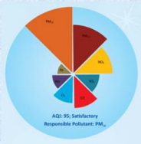
Air Quality Index
1

Site map of CAAQM stations operated by KSPCB in Bengaluru
CAAQM Stations: Hebbal, Jayanagar, KAVIKA, NIMHANS, Silkboard, Nisarga Bhavan (Basaveshwaranagar) & City Railway Station(CRS) 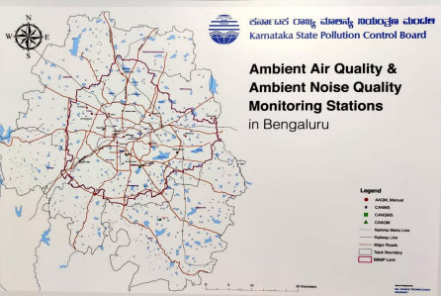Parameter-wise data tables of CAAQM Stations
I) Hebbal
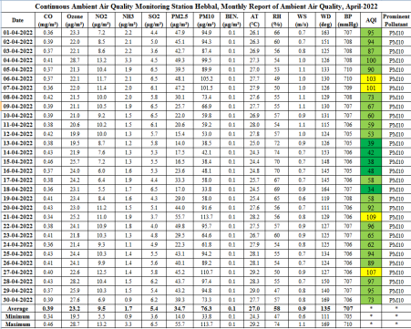 2

II) Jayanagar
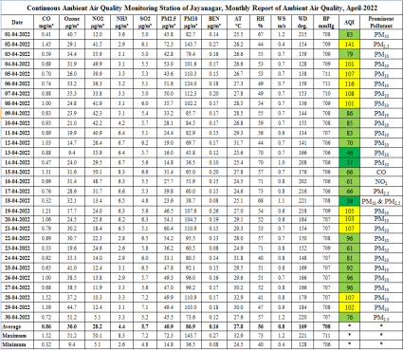
III) KAVIKA
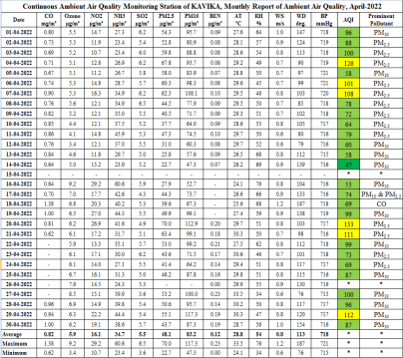 3

IV) NIMHANS
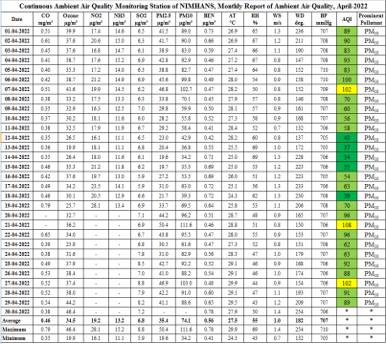V) Silkboard
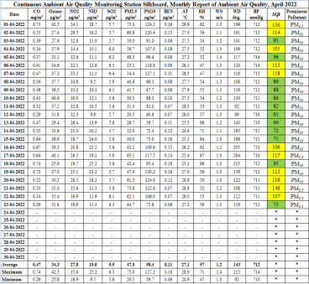 4

VI) Nisarga Bhavan
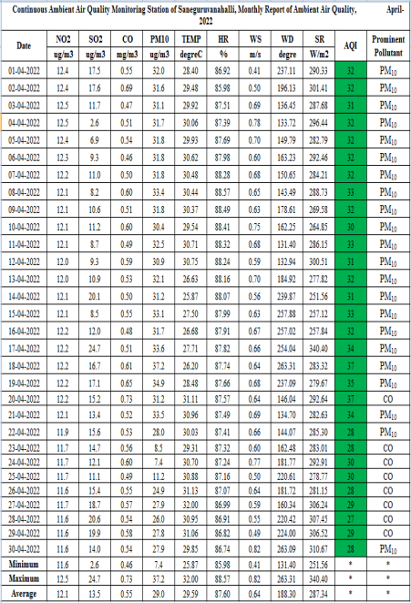 5

VII) City Railway Station.
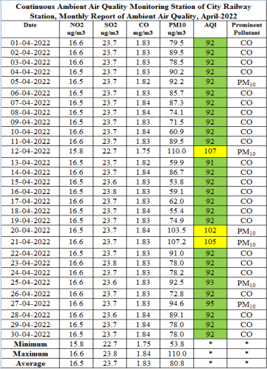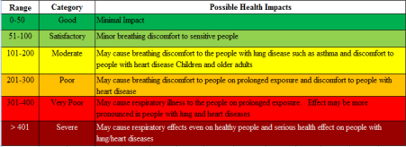 6

Daily AQI values of CAAQM Stations in Bengaluru(April-2022)
Daily AQI Values of Bengaluru (April-2022)
Date/  Station  Name | City  Railway  Station,  Majestic | Nisarga Bhavan, Saneguruvanahalli | Veterinary College,  Hebbal | Shalini  Ground,  Jayanagar | KAVIKA, Mysore  Road | NIMHANS | H.S.R  Layout,  Near  Central  Silkboard
01-04-2022 | 92 | 32 | 95 | 83 | 96 | 89 | 150
02-04-2022 | 92 | 32 | 94 | 141 | 88 | 90 | 114
03-04-2022 | 92 | 31 | 87 | 79 | 100 | 83 | 91
04-04-2022 | 92 | 32 | 100 | 101 | 126 | 93 | 105
05-04-2022 | 92 | 32 | 90 | 107 | 58 | 83 | 96
06-04-2022 | 92 | 32 | 103 | 116 | 101 | 100 | 113
07-04-2022 | 92 | 32 | 101 | 108 | 108 | 102 | 118
08-04-2022 | 92 | 33 | 73 | 101 | 78 | 70 | 86
09-04-2022 | 92 | 32 | 67 | 86 | 72 | 60 | 88
10-04-2022 | 92 | 30 | 60 | 85 | 64 | 56 | 86
11-04-2022 | 92 | 33 | 59 | 83 | 79 | 58 | 82
12-04-2022 | 107 | 31 | 53 | 70 | 60 | 43 | 61
13-04-2022 | 91 | 32 | 39 | 46 | 58 | 37 | 60
14-04-2022 | 92 | 31 | 42 | 37 | 47 | 34 | 72
15-04-2022 | 92 | 33 | 38 | 66 | * | 35 | 75
16-04-2022 | 92 | 32 | 48 | 61 | 53 | 54 | 106
17-04-2022 | 92 | 34 | 58 | 66 | 74 | 63 | 117
18-04-2022 | 92 | 37 | 34 | 39 | 69 | 39 | 95
19-04-2022 | 92 | 35 | 58 | 105 | 99 | 70 | 113
20-04-2022 | 102 | 37 | 92 | 103 | 133 | 96 | 116
21-04-2022 | 105 | 34 | 109 | 107 | 111 | 108 | 146
22-04-2022 | 92 | 28 | 96 | 96 | 99 | 96 | 107
23-04-2022 | 92 | 28 | 65 | 61 | 73 | 62 | 75
24-04-2022 | 92 | 30 | 62 | 81 | 69 | 63 | *
25-04-2022 | 93 | 30 | 94 | 92 | 87 | 92 | *
26-04-2022 | 92 | 28 | 89 | 96 | * | 88 | *
27-04-2022 | 95 | 29 | 107 | 96 | 100 | 102 | *
28-04-2022 | 92 | 27 | 97 | 107 | 96 | 91 | *
29-04-2022 | 92 | 29 | 95 | 102 | 112 | 89 | *
30-04-2022 | 92 | 28 | 73 | 76 | 87 | * | *
Min | 91 | 27 | 34 | 37 | 47 | 34 | 60
Max | 107 | 37 | 109 | 141 | 133 | 108 | 150

* Data Not Available
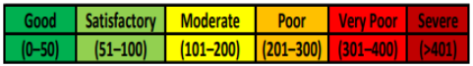 7

AQI Trend Bengaluru, April -2022
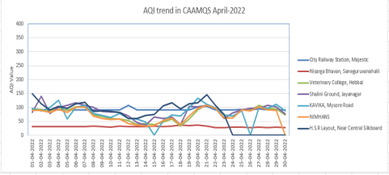
Hebbal, Jayanagara, KAVIKA, NIMHANS, Silkboard,
Nisargabhavan(Basaveshwaranagara), City Railway Station(CRS)
Data Analysis of Ambient Air Quality:
❖ Particulate Matter(PM₁₀): Recorded within permissible limit at Saneguruvanahalli, Nisarga Bhavan. However, there is slight variation inPM₁₀values at different stations viz., City Railway Station(3 days), Hebbal(4 days), Jayanagar(10 days), KAVIKA(3 days), NIMHANS(3 days), Central Silk Board(11 days). The exceedence of PM₁₀is attributed due to vehicular movement and re-suspension of Road dust.
❖ Particulate Matter(PM_{2.5}): Recorded within permissible as per NAAQS 2009 standards in the three monitored station viz., Hebbal, NIMHANS and City Railway Station.
❖ Sulphur Dioxide(SO₂): Recorded within permissible limit in all stations across Bengaluru as per NAAQS 2009 standards.
❖ Nitrogen Dioxide(NO₂) Recorded within permissible limit in all stations across Bengaluru as per NAAQS 2009 standards.
❖ Ammonia(NH₃): Observed within permissible limit in all the five monitored stations viz., Hebbal, Jayanagar, KAVIKA, NIMHANS & Silkboard as per NAAQS 2009 standards.
❖ Carbon Monoxide(CO): Observed 8-hourly concentration values within the permissible limits in all stations across Bengaluru as per NAAQS 2009 Standard.
❖ Ozone(O₃): Observed within permissible limit in all the five monitored stations viz., Hebbal, Jayanagar, KAVIKA, NIMHANS & Silkboard as per NAAQS 2009 standards.
8

Concentration ranges of Ambient Air Quality Parameters of Bengaluru Stations
The concentration ranges for pollutants of CAAQM stations having 24 hourly standard limits are presented in below table based on detailed tabulated date.
Table-1 Range of 24-hourly Averages for Notified Parameters monitored in April-2022, Bengaluru
Parameters | Hebbal |  | Jayanagar |  | KAVIKA |  | NIMHANS |  | Silkboard |  | Nisarga  Bhavan |  | City  Railway  station
Parameters | MIN | MAX | MIN | MAX | MIN | MAX | MIN | MAX | MIN | MAX | MIN | MAX | MIN | MAX
PM₁₀(µg/m³) | 33.8 | 113.7 | 36.5 | 143.7 | 47.3 | 117.3 | 34.2 | 111.6 | 59.7 | 127.1 | 7.4 | 37.2 | 53.8 | 110.0
PM_{2.5}(µg/m³) | 14.0 | 55.7 | 14.8 | 72.3 | 22.7 | 70.0 | 19.6 | 50.4 | 20.5 | 75.0 | * | * | * | *
SO₂(µg/m³) | 3.6 | 6.5 | 4.8 | 7.2 | 3.6 | 6.5 | 5.9 | 8.8 | 5.6 | 6.5 | 2.6 | 24.7 | 22.7 | 23.8
NO₂(µg/m³) | 5.5 | 13.2 | 5.1 | 50.1 | 10.7 | 29.2 | 16.1 | 28.1 | 16.9 | 35.6 | 11.6 | 12.5 | 15.8 | 16.6
NH₃(µg/m³) | 0.9 | 3.3 | 2.6 | 8.3 | 23.4 | 60.6 | 11.1 | 15.2 | 9.5 | 25.2 | * | * | * | *
Note: * Parameters not monitored
CO, Ozone and Benzene not included as there is no 24 hourly permissible limits in NAAQM

Air Quality Index(AQI)
AQI of Bengaluru was found largely lying in Good &Satisfactory at all locations of Bengaluru. However, there was slight increase in PM₁₀ values at Jayanagar, Silkboard and KAVIKA for few day and that may be due high vehicular movement and Resuspension of road dust at that particular period of time.
Table-2 AQI Values of CAAQM stations in Bengaluru for the month of April-2022
AQI  Categories | Range | Hebbal | Jayanagar | KAVIKA | NIMHANS | Silkboard (23 days) | Nisarga Bhavan | City  Railway station
Good | (0-50) | 5 | 3 | 1 | 5 | - | 30 | -
Satisfactory | (51-100) | 21 | 16 | 21 | 20 | 12 | - | 27
Moderate | (101-200) | 4 | 11 | 6 | 4 | 11 | - | 3
Poor | 201-300 | - | - | - | - | - | - | -
Very Poor | 301-400 | - | - | - | - | - | - | -
Severe | (> 401) | - | - | - | - | - | - | -

Meteorological Parameters
Daily average wind speed was observed in the range 0.4 m/s – 1.1 m/s. Monthly average temperature was 29.59˚C with minimum daily average as 24.1˚C and maximum as 33.5˚C recorded. Monthly average relative humidity was 87.60% with maximum daily average as 88.57 % and minimum as 34% recorded.
Table-3 Monthly Range and Average for Metrological Parameters in Bengaluru, April-2022
Parameters(Unit)* | Average | Maximum | Minimum
Wind Speed(m/s) | 1.2 | 1.1 | 0.4
Temperature(ºC) | 29.59 | 33.5 | 24.1
Relative Humidity(%) | 87.60 | 88.57 | 34

* Data of 6 Stations
9

Windrose diagrams: The graphical charts that characterise the speed and direction of wind at the CAAQM Stations.

10

INFERENCE: The overall air quality in Bengaluru was Good and Satisfactory. CAAQM STATIONS- Parameters Monitored
Sl.  No. | Stations | Types of activities around location  (Residential/Commercial/  Traffic/Industrial) | Parameters Monitored
1 | Hebbal | Sensitive | SO₂, NO₂, PM₁₀, PM_{2.5}, NH₃, CO, O₃, Benzene& Meteorological  parameters
2 | Jayanagar | Commercial | SO₂, NO₂, PM₁₀, PM_{2.5}, NH₃, CO, O₃, Benzene& Meteorological  parameters
3 | KAVIKA | Commercial | SO₂, NO₂, PM₁₀, PM_{2.5}, NH₃, CO, O₃, Benzene& Meteorological  parameters
4 | NIMHANS | Sensitive | SO₂, NO₂, PM₁₀, PM_{2.5}, NH₃, CO, O₃, Benzene& Meteorological  parameters
5 | Silkboard | Residential cum Commercial | SO₂, NO₂, PM₁₀, PM_{2.5}, NH₃, CO, O₃, Benzene& Meteorological  parameters
6 | Nisarga  Bhavan | Residential | SO₂, NO₂, PM₁₀, CO
7 | City Railway Station | Commercial | SO₂, NO₂, PM₁₀, CO & Meteorological  parameters

Broad guidelines for Public
AQI is an initiative intended to enhance public awareness and involvement in efforts to improve air quality. People can contribute by maintaining vehicles properly (e.g. get PUC checks, replace car air filter, maintain right tyres pressure), following lane discipline & speed limits, avoiding prolong idling and turning off engines at red traffic signals. The following are some of the best practices that are to be followed to maintain / improve the air Quality.
1) Avoid using private vehicles viz., cars, bikes and instead use public transports viz., Public buses and Metro services.
2) Encourage carpool and use smaller vehicles (e.g. avoid SUVs).
3) Construction projects shall compulsorily put up enclosures and barriers around their project and carry out regular water sprinkling to supress dust. Air purifier can also be installed to mitigate dust pollution. 11

4) Road dust management by using mechanized road sweeping and water sprinkling system, etc., The Civic bodies shall regularly remove the silt and muck dumped on the roadside and pavements, besides levelling & asphalting of Roads and filling up of potholes should be taken up on top priority.
5) Unnecessary parking of vehicles on roadside junctions and circles should be avoided of around 50 to 100 meters.
6) Avoid open burning of garbage wastes, tree leaves, branches, trash, tyres etc., especially near roadsides, lakes and water bodies, open ground, vacant land and Parks.
NATIONAL AMBIENT AIR QUALITY STANDARDS
Concentration in Ambient Air
Sl.
_{No.} Pollutants
Time
Weighted Average
Industrial, Residential Rural and other Areas
Ecologically Sensitive Area (Notified by Central
Government)
Methods of Measurement

1 | Sulphur Dioxide (SO₂) µg/m³ | Annual * | 50 | 20 | -Improved west and Gaeke Method  – Ultraviolet Fluorescence
1 | Sulphur Dioxide (SO₂) µg/m³ | 24 Hours** | 80 | 80 | -Improved west and Gaeke Method  – Ultraviolet Fluorescence
2 | Nitrogen Dioxide (NO₂) µg/m³ | Annual * | 40 | 30 | -Jacob & Hochheiser Modified (NaOH NaAsO2) Method  -Gas phase Chemiluminescence
2 | Nitrogen Dioxide (NO₂) µg/m³ | 24 Hours** | 80 | 80
3 | Particulate Mater (Size less than 10 µm) or PM10 µg/m³ | Annual * | 60 | 60 | -Gravimetric  -TECOM  -Beta attenuation
3 | Particulate Mater (Size less than 10 µm) or PM10 µg/m³ | 24 Hours** | 100 | 100 | -Gravimetric  -TECOM  -Beta attenuation
4 | Particulate Mater (Size less than 10 µm) or PM _{2.5} µg/m³ | Annual * | 40 | 40 | -Gravimetric  -TECOM  -Beta attenuation
4 | Particulate Mater (Size less than 10 µm) or PM _{2.5} µg/m³ | 24 Hours** | 60 | 60 | -Gravimetric  -TECOM  -Beta attenuation
5 | Ozone (O₃) µg/m³ | 8 Hours * | 100 | 100 | -UV Photometric  -Chemical Method
5 | Ozone (O₃) µg/m³ | 1 Hours** | 180 | 180 | -UV Photometric  -Chemical Method
6 | Lead (Pb) µg/m³ | Annual * | 0.5 | 0.5 | -AAs/ICP Method after sampling on EPM 2000 or equivalent filter paper  -ED-XRF using Teflon filter
6 | Lead (Pb) µg/m³ | 24 Hours** | 1 | 1
7 | Carbon Monoxide (CO) µg/m³ | 8 Hours * | 02 | 02 | -Non dispersive Infrared (NDIR)  -Spectroscopy
7 | Carbon Monoxide (CO) µg/m³ | 1 Hours** | 04 | 04 | -Non dispersive Infrared (NDIR)  -Spectroscopy
8 | Ammonia (NH₃) µg/m³ | Annual * | 100 | 100 | -Chemiluminescence  -Indophenol Blue Method
8 | Ammonia (NH₃) µg/m³ | 24 Hours** | 400 | 400 | -Chemiluminescence  -Indophenol Blue Method
9 | Benzene (C6H6) µg/m³ | Annual * | 05 | 05 | -Gas Chromatography (GC) based  continuous analyzer  -Adsorption and desorption followed by GC analysis
10 | Benzo (a) Pyrene (BaP) µg/m³ | Annual * | 01 | 01 | -Solvent extraction followed by HPLC/GC analysis
11 | Arsenic (As) µg/m³ | Annual * | 06 | 06 | -AAS/ICP Method after sampling on EPM 2000 or equivalent filter paper
12 | Nickel (Ni) ng/m³ | Annual * | 20 | 20 | -AAS/ICP Method after sampling on EPM 2000 or equivalent filter paper

====********====
12

